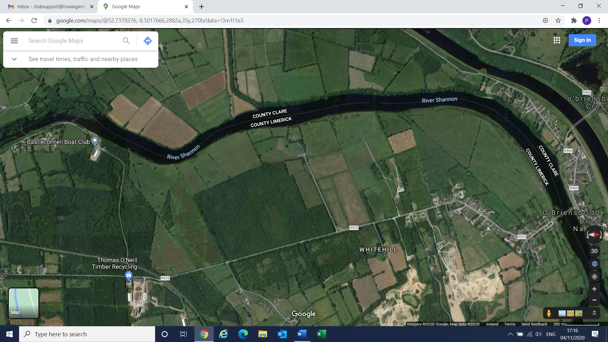
In case of Emergency Dial 999 or 112, ask for Fire Service, Ambulance or River Rescue, give nearest Eircode for location!
Castleconnell Boat Club Emergency Action Plan Emergency Services Rendezvous Points
Emergency Rendezvous Point 2
Limerick Slip V94 WCD1
Emergency Rendezvous Point 1
Boat Club V94 662A

Emergency Rendezvous Point 3
O’ Briensbridge
V94 T4AT

